Key Points of the Document
What is a Quistclose Trust?
A Quistclose trust arises when funds are advanced for a specific purpose, creating a dual-layer trust structure:
Primary Trust: The recipient holds the funds for the specified purpose.
Secondary (Resulting) Trust: If the purpose fails, the funds are held in trust for the transferor.
This structure is particularly important in insolvency scenarios, where it prevents the funds from being treated as part of the transferee’s general assets, ensuring they revert to the transferor.

How Does a Quistclose Trust Differ from a Loan or Contractual Agreement?
Key Distinctions
Proprietary Interest:
In a loan, the borrower receives full beneficial ownership of the funds and can use them as they see fit, subject to repayment obligations.
In a Quistclose trust, the transferor retains a proprietary interest in the funds until the purpose is fulfilled.
Specific Purpose Requirement:
A Quistclose trust is contingent on the funds being earmarked for a defined purpose. If the purpose fails, the funds do not become part of the recipient's general assets.
A loan typically has no such restriction; the borrower is free to use the funds for any purpose unless explicitly agreed otherwise.
Fiduciary Obligations:
In a Quistclose trust, the recipient acts as a fiduciary, obligated to use the funds strictly for the specified purpose.
In a loan agreement, the borrower owes no fiduciary duties to the lender; their obligation is purely contractual.
Treatment in Insolvency:
Loaned funds form part of the borrower’s general assets in insolvency, making the lender an unsecured creditor.
Funds under a Quistclose trust are protected as trust property, ensuring the transferor's proprietary claim takes precedence over other creditors.

Judicial Interpretations
Barclays Bank Ltd v Quistclose Investments Ltd [1970]
Facts: Rolls Razor borrowed funds from Quistclose Investments to pay a declared dividend, placing the money in a separate account earmarked for this purpose. Rolls Razor went into liquidation before the dividend was paid.
Held: A Quistclose trust existed. The funds were held on trust for the stated purpose, and upon its failure, the funds reverted to Quistclose Investments under a resulting trust.
Reasoning: Lord Wilberforce distinguished between loans (where the borrower has full beneficial ownership) and trusts (where funds are restricted for a specific purpose).

Twinsectra Ltd v Yardley [2002]
Facts: Twinsectra advanced funds through a solicitor for property purchases. The solicitor misused the funds.
Held: The funds were held in a Quistclose trust.
Reasoning: Lord Millett emphasized that the borrower never acquired beneficial ownership, as the funds were held on a resulting trust. This preserved the lender's proprietary interest.

Re EVTR [1987]
Facts: Funds advanced for purchasing business equipment remained unspent when the intended transaction failed.
Held: The funds were subject to a Quistclose trust and returned to the transferor.
Reasoning: The primary purpose of the funds failed, and a resulting trust arose in favor of the transferor.

Scholarly Commentary
Lord Wilberforce (Quistclose Case):
Differentiated between loans and Quistclose trusts by focusing on the intention to retain beneficial ownership and the earmarking of funds for a specific purpose.
Lord Millett (Twinsectra):
Clarified that Quistclose trusts are resulting trusts, preserving the transferor's proprietary interest in the funds.
Argued that fiduciary duties arise when funds are not at the free disposal of the transferee.
William Swadling:
Criticized the classification of Quistclose trusts as resulting trusts, arguing they are better understood as express trusts for a purpose.
Peter Birks and Robert Chambers:
Advocated unjust enrichment as the rationale for Quistclose trusts, emphasizing the prevention of unjust benefits to the recipient when the purpose fails.

Statutory Context
While no specific statutes directly govern Quistclose trusts, principles of equity and insolvency law ensure that funds earmarked for specific purposes are treated differently from general assets.
For instance, Insolvency Rules 1986 (UK) influence the application of proprietary rights in trust funds during insolvency proceedings.

Key Themes from the Document
Fiduciary vs. Contractual Obligations:
Fiduciary obligations in Quistclose trusts require the recipient to use the funds strictly for their designated purpose. Contracts of loan do not impose such obligations.
Role in Commercial Transactions:
Quistclose trusts provide a safeguard in insolvency, ensuring that transferors retain proprietary claims over funds, unlike unsecured creditors in loan agreements.
Judicial Evolution:
From Quistclose to Twinsectra, courts have refined the doctrine, emphasizing the proprietary and fiduciary aspects of these trusts.
Equity’s Adaptability:
The Quistclose trust exemplifies equity’s flexibility in addressing commercial arrangements, balancing legal certainty with fairness.

How to Differentiate Quistclose Trusts from Loans
Intention of the Transferor: Look for evidence that the transferor intended to retain control or ownership over the funds until the purpose is fulfilled.
Earmarked Purpose: If funds are specifically allocated for a defined purpose, a Quistclose trust is likely to arise.
Control Over Funds: Quistclose trusts impose limits on how the funds can be used, while loans provide full discretion to the borrower.
Treatment on Failure: For Quistclose trusts, funds revert to the transferor; for loans, the recipient retains ownership and owes a debt.

Difference from resulting trusts
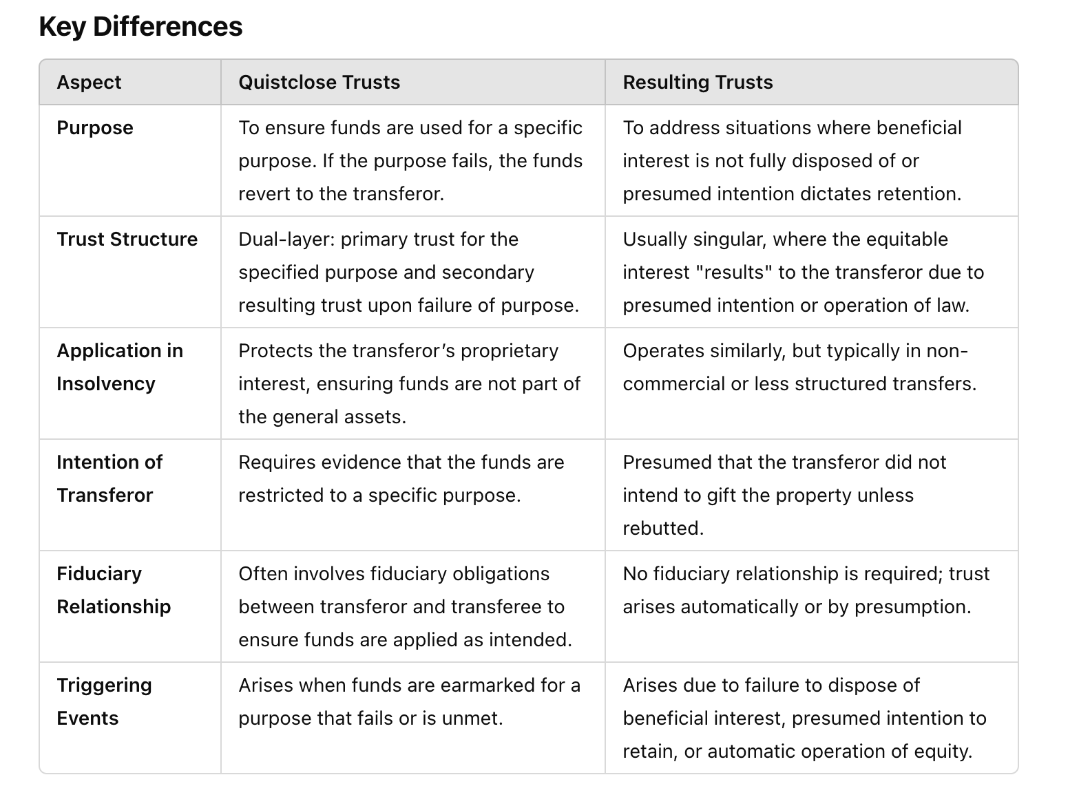
Key Factors to Differentiate Between Trusts and Contracts
1. Intention to Create a Trust
Trust: The arrangement must indicate that the recipient is holding the funds for a specific purpose or on behalf of the transferor. The transferor must intend to retain proprietary rights over the funds until the purpose is fulfilled.
Example: If the contract explicitly states that the funds are to be kept in a separate account and used exclusively for a particular purpose (e.g., paying creditors), it may create a trust.
Contract: If the funds are advanced with no intention to retain ownership and the recipient can use the funds as they see fit (subject to repayment or other terms), it’s likely a contractual arrangement.
Example: A loan agreement requiring repayment upon insolvency is a contractual obligation, not a trust.

2. Separation of Funds
Trust: Funds held in a separate account or specifically designated for a purpose are strong indicators of a trust. This separation signifies that the funds are not part of the recipient’s general assets.
Case Reference: In Barclays Bank v Quistclose Investments Ltd, funds were deposited in a special account, earmarked for a specific purpose, creating a trust.
Contract: If the funds are mixed with the recipient’s general assets and not segregated, it suggests a loan or contractual relationship.

3. Fiduciary Duties
Trust: If the recipient has fiduciary obligations to act in the interest of the transferor and use the funds strictly for the stated purpose, this supports the existence of a trust.
Case Reference: In Twinsectra Ltd v Yardley, the solicitor was deemed a fiduciary because he held the funds on a Quistclose trust for a specific purpose.
Contract: In a standard contract, the recipient owes no fiduciary duties to the transferor. Their obligations are limited to the terms of the agreement.

4. Failure of Purpose
Trust: If the specific purpose fails (e.g., the funds cannot be used as intended), the money reverts to the transferor under a resulting trust.
Case Reference: In Re EVTR, unspent funds intended for equipment purchase reverted to the transferor when the purpose failed.
Contract: If the arrangement is contractual, the funds form part of the recipient’s general assets, and the transferor becomes an unsecured creditor in insolvency.

5. Application in Insolvency Scenarios
If It’s a Trust:
The transferor retains a proprietary claim over the funds, which are excluded from the recipient’s general assets in insolvency.
The transferor has priority over other creditors because the funds are not treated as part of the insolvent estate.
If It’s a Contract:
The transferor becomes an unsecured creditor, ranked behind secured and preferential creditors. The funds form part of the recipient’s general assets and are distributed accordingly.

6. Practical Examples
Trust Scenario:
A construction company receives funds under a contract requiring that the money be kept in a separate account to pay subcontractors. If the company becomes insolvent without using the funds, the money is subject to a trust and reverts to the transferor.
Contractual Loan Scenario:
A business loans money to another under an agreement that repayment is due in installments. If the recipient becomes insolvent, the transferor has no proprietary claim over the funds and must file as an unsecured creditor.

7. Case Law Guidance
Barclays Bank v Quistclose Investments Ltd
Trust: The specific earmarking of funds for dividend payments created a trust. The purpose’s failure meant the funds reverted to the transferor.
Re Kayford [1975]
Trust: A mail-order company that placed customer payments in a separate account to ensure refunds upon insolvency was found to have created a trust.
Twinsectra Ltd v Yardley
Trust: Funds advanced with strict conditions for property purchases were held on trust for the lender. The borrower’s misuse triggered a breach of trust.
Re Goldcorp Exchange Ltd [1995]
No Trust: Customers of an insolvent gold dealer were found to have no proprietary claim because the funds were not segregated or held for a specific purpose.

8. How to Ensure It’s a Trust, Not a Contract
To create a trust in a contractual setting, ensure the following:
1. Explicit Language: Include terms that the funds are held on trust and for a specific purpose.
2. Segregated Funds: Keep the funds in a separate account or otherwise distinct from the recipient’s general assets.
3. Defined Purpose: Clearly state the intended purpose of the funds and specify that they are to revert to the transferor if the purpose fails.
4. Control and Ownership: Ensure the transferor retains beneficial ownership until the purpose is fulfilled.

What Does "Retain Ownership" Mean in Trusts?
Ownership in Trusts:
In a trust, the transferor retains beneficial ownership of the funds (or rights) unless explicitly transferred to the recipient.
The recipient holds the funds as a trustee, meaning they only have legal ownership and must use the funds according to the terms of the trust.
Ownership in Contracts (Loans):
In a loan or contractual arrangement, the transferor gives full ownership (legal and beneficial) to the recipient.
The recipient can use the funds as they see fit, subject to the obligation to repay according to the loan terms.

Examples: Trust vs. Contractual Loan
1. Trust (Funds as Separate Assets)
Scenario:
You, A, give £10,000 to B on the condition that B uses the money exclusively to repay C (B's creditor).
Key Features:
Intention: You do not intend to transfer full ownership of the money to B. Instead, B holds the money for the specific purpose of repaying C.
Segregation: The funds must remain separate from B's general assets (e.g., kept in a distinct account).
Ownership: You retain beneficial ownership of the funds until the purpose (repayment to C) is fulfilled.
Failure of Purpose: If B does not use the money to pay C (e.g., C rejects payment or B becomes insolvent), the funds revert to you under a resulting trust.
Outcome in Insolvency:
If B becomes insolvent before paying C, the £10,000 is excluded from B's general assets.
You have a proprietary claim over the money, and it does not go to B’s creditors.

2. Contractual Loan (Funds as General Assets)
Scenario:
You, A, lend £10,000 to B with the expectation that B will repay you in monthly installments over one year.
Key Features:
Intention: You transfer full ownership (legal and beneficial) of the £10,000 to B. B can use the funds for any purpose, including repaying debts.
No Segregation: The money becomes part of B’s general assets and is not kept separate.
Ownership: B owns the money outright and owes you a debt under the loan agreement.
Failure of Purpose: If B becomes insolvent, the loan repayment obligation is a contractual liability.
Outcome in Insolvency:
If B becomes insolvent before repaying the loan, the £10,000 forms part of B's general assets.
You are an unsecured creditor, ranking behind secured and preferential creditors.

